

**Technical Guide**

**2025 ORA Trails Fest**

**August 15-17, 2025**

ORA Trails Fest is a class 2 XCO and class 3 XCC UCI event that will be held Friday, August 15 and Saturday, August 16, 2025 in La Crosse, WI. WORS series racing will be on Sunday, August 17, 2025 and is a USAC points only event.

Online registration can be found at www.bikereg.com/ora-trails-fest, and we encourage racers to register online before midnight, Wednesday, August 13, 2025. On-site registration will be an additional fee ($20) and USAC category racers will not be eligible for call-ups. We recommend racers bring cash or check as credit card payment may be difficult with our remote location. On-site registration closes 30 minutes before each event. Please note, you will be using the same set of numbers for both Friday AND Saturday.

**Table of Contents**

1 Location 1

1.1 Venue 1

1.2 Team/Expo Space 1

2 Event Schedule 1

2.1 Thursday - August 14 // Registration and Open Practice 1

2.2 Friday - August 15 // XCC – Short Track (UCI and WORS Racing) 1

2.3 Saturday - August 16 // AM Enduro (WORS Racing) // PM XCO – Cross Country (UCI Racing) 2

2.4 Sunday, August 17 // XCO – Cross Country (WORS Racing) 2

2.5 Organization 2

3 Travel 2

3.1 Airports 3

3.2 Lodging 3

3.3 Camping 3

4 Event Procedures 3

4.1 Event Rules 3

4.2 Racer Check-in and Plate Pick-up 3

4.3 Course Inspection and Pre-ride 3

4.4 Staging and Call-up 4

4.5 Feed Zone / Tech. Asst. Zone Access (FZ/TAZ) 4

4.6 Course 4

4.7 Podium Ceremony 5

4.8 Bike Wash 5

4.9 The 80% Rule 5

4.10 Anti-doping 6

4.11 Results / Timing 6

4.12 First Aid and Hospital 6

4.13 Officials 6

4.14 UCI MTB Points 6

4.15 UCI Prize List / Distribution 7

# Location

## Venue

Hixon Forest Trails  
711 Cty Rd FA  
La Crosse, WI 54601

ORA Trails Fest is held on public trails, owned by the City of La Crosse and maintained by ORA Trails, a 501(c)3 non profit.

## Team/Expo Space

Will be available to be purchased from the registration page on [www.bikereg.com/ora-trails-fest](http://www.bikereg.com/ora-trails-fest) under “merchandise.” Vehicles must enter before racing begins, and stay until racing has concluded for the day.

# Event Schedule

The events include a combination of UCI and WORS points:

|  |  |
| --- | --- |
| UCI Events | WORS Events |
| * XCC – Short Track (Friday) * XCO – Cross Country (Saturday) | * XCC – Short Track (Friday) * Enduro (Saturday) * XCO – Cross Country (Sunday) |

## Thursday - August 14 // Registration and Open Practice

|  |  |
| --- | --- |
| Time | Event |
| 9:00 a.m. – 12:00 p.m. | Registration/Check-in open |
| 11:00 a.m. – 1:00 p.m. | UCI course inspection by commissaires |
| 1:00 p.m. – 5:00 p.m. | Open Practice - XCO |

*\*Please use caution as course workers may be on course.*

## Friday - August 15 // XCC – Short Track (UCI and WORS Racing)

|  |  |
| --- | --- |
| Time | Event |
| 8:00 a.m. | Registration/Check-in open // Course open for pre-ride XCC & XCO |
| 11:00 a.m. – 12:45 p.m. | Official Training - XCC only (XCO course is open other than XCC) |
| 1:00 p.m. – 1:20 p.m. | 15-16, 17-18 Women (20 minutes) |
| 1:30 p.m. – 1:50 p.m. | 15-16, 17-18 Men (20 minutes) |
| 2:00 p.m. – 2:20 p.m. | UCI Women Elite (UCI Class 3) (20 minutes) |
| 2:30 p.m. – 2:50 p.m. | UCI Men Elite (UCI Class 3) (20 minutes) |
| 3:00 p.m. – 3:20 p.m. | Non-UCI Open 19+ Women (20 minutes) |
| 3:30 p.m. – 3:50 p.m. | Non-UCI Open 19+ Men (20 minutes) |
| 4:00 p.m. – 4:15 p.m. | Junior Women 7-14 (15 minutes) |
| 4:30 p.m. – 4:45 p.m. | Junior Men 7-14 (15 minutes) |
| 5:00 p.m. – 7:00 p.m. | PM Open Practice |
| 5:30 p.m.. | Rider/Team Manager's Meeting |

*\*Staging for all races will begin 15 min. before start times, times subject to change*

## Saturday - August 16 // AM Enduro (WORS Racing) // PM XCO – Cross Country (UCI Racing)

|  |  |
| --- | --- |
| Time | Event |
| 8:00 a.m. | Registration/Check-in open // Course open for pre-ride XCO, except where Enduro is happening (OB1/Darkside and Twister near #28) |
| 8:00 a.m. – 9:00 a.m. | Enduro Pre-Ride Open |
| 9:00 a.m. – 12:00 p.m. | Enduro Racing |
| 12:30 p.m. – 6:30 p.m. | XCO Racing |
| 12:30 p.m. | Junior Women 15-16 |
| 12:31 p.m. | Junior Women 13-14 |
| 12:32 p.m. | Women Open |
| 2:00 p.m. | Junior Men 15-16 |
| 2:01 p.m. | Junior Men 13-14 |
| 2:02 p.m. | Men Open |
| 4:00 p.m. | UCI Women Elite (UCI Class 2) |
| 4:01 p.m. | UCI Women 17-18 (UCI Class 2) |
| 6:00 p.m. | UCI Men Elite (UCI Class 2) |
| 6:01 p.m. | UCI Men 17-18 (UCI Class 2) |

*\*Staging for all races will begin 15 min before start times*

*\*\*Awards will be 30 min after the start of the next race, times subject to change*

## Sunday, August 17 // XCO – Cross Country (WORS Racing)

|  |  |
| --- | --- |
| Time | Event |
| 8:00 a.m. – 2:00 p.m. | Registration/Check-in open // Course open for pre-ride |
| 8:30 a.m. | Kids Comp |
| 9:00 a.m. | Newbie + Citizen Women |
| 10:00 a.m. | Newbie + Citizen Men |
| 11:00 a.m. | Sport Men (Cat 2) |
| 12:30 p.m. | Sport + Elite Women, Junior Elite Women (Cat 1) |
| 2:00 p.m. | Comp + Jr. Elite Boys (Cat 1) + Elite Men (Cat 1) |

*\*Staging for all races will begin 15 min before start times,*

*\*\*Awards will be 30 min after the start of the next race, times subject to change*

## Organization

|  |  |  |  |
| --- | --- | --- | --- |
| Position | Name | Phone | Email |
| Race Director | Chris Stindt | 920-379-5197 | chris@smithsbikes.com |
| Registration | Heather Rainer | 262-210-0162 | heather@wisconsinbikefed.org |
| UCI Chief Commissaire | Ugur Tosun | 218-269-6556 | ugurht@gmail.com |
| WORS / Trek | Marcus Warrington | 651-764-1036 | Marcus_Warrington@trekbikes.com |
| Medical | David Mangan | 414-423-1867 | dmangan@wi.rr.com |
| Timing / Results | Andy Allstadt, All Stat Timing | 608-616-9472 | andrew.allstadt@gmail.com |
| Course Director | Erik Pueschner | 608-385-7267 | erik@smithsbikes.com |
| Volunteer Coordinator | Randi Pueschner | 608-386-7448 | randi@smithsbikes.com |

# Travel

## Airports

* La Crosse is home to a regional airport (airport code LSE) with service to Chicago and is a 15 minute drive to the venue.
* Madison WI (airport code MSN), it is 2 hours from the venue.
* Minneapolis/St. Paul (airport code MSP) is 2 hours and 30 minutes from the venue.

All airports have major rental car companies available, and it is recommended that travelers book their rental cars before arriving.

## Lodging

La Crosse is home to many hotels. There are options downtown (a 5-minute drive to the venue) and by Interstate 90 (a 10-minute drive to the venue). There are many AirBnB/VRBO options nearby as well.

## Camping

Rough camping is available on-site, with portable toilets provided. Tent/RV/Van camping is $50 for 3 nights. Camping is reservable at bikereg.com/ora-trails-fest. No generators after 8 pm.

# Event Procedures

## Event Rules

This event is held under UCI and USA Cycling permits, and governed by UCI and USAC rules. UCI / USAC scale of penalties apply to the respective races. UCI rules can be downloaded from [www.uci.org](http://www.uci.org), USAC rules from [www.usacycling.org](http://www.usacycling.org). Men Elite,Women Elite, Men Junior 17-18 and Women Junior 17-18 races are designated UCI C2 events. Riders entering these races must have a UCI license. All other races are run under USAC rules and a domestic USA Cycling license is required. One-Day licenses are available for an $15 additional fee at the time of registration - either on-site or through BikeReg: [www.bikereg.com/ora-trails-fest](http://www.bikereg.com/ora-trails-fest)

## Racer Check-in and Plate Pick-up

Racer check-in and plate pick-up will take place at the registration tent - review the schedule for dates/times.

Each cyclist is given a handlebar plate with their registration which must be kept throughout the event. At Racer Check-in and Plate Pick-up, the cyclists must present their license to the officials/staff.

Any modification to the plate (cut, sticker, etc.) may result in the replacement of the plate at the cyclist's expense. The athlete who does not have their plate at a race will have to pay a fee of $10 to obtain a new plate.

## Course Inspection and Pre-ride

* All racers must display their number plates and be previously registered for their events while on the venue.
* All coaches and non-racers must sign a waiver BEFORE they are allowed to ride on the property.
* While on course, riders should use caution at all pedestrian course crossings, as course marshals will not be present until competition begins.

## Staging and Call-up

The call-up procedure will be as follows:

1. UCI XCO ranking
2. USA Cycling National Champion
3. USAC XC rankings*
4. Foreign National Team Riders

* After all riders with UCI points and the next 10 USA Cycling ranked riders (above), the top 2 riders (as provided by a national representative) from each nation (those not holding a USA Cycling license), will be slotted in. Then, the process continues.

## Feed Zone / Tech. Asst. Zone Access (FZ/TAZ)

Only authorized personnel are allowed access to the FZ/TAZ. In non-UCI events, the area is only to be used as a Feed Zone as per USAC regulations.

Common sense will be the rule. The FZ/TAZ Official will have full authorization to deny access to any person who interferes or hinders operations in the zone. FZ/TAZ is not a spectator spot.

## Course

The 4.75 mile course has been designed and constructed over the past 20 years specifically for cross-country racing. It takes full advantage of the natural features of the area, including multiple bluff climbs. Features include sustained climbs and technical rock gardens, with plenty of berms and jumps to keep racers on their toes while battling for position. Special attention has been given to create plenty of passing opportunities throughout the course, which allows safe and fair racing for all participants.

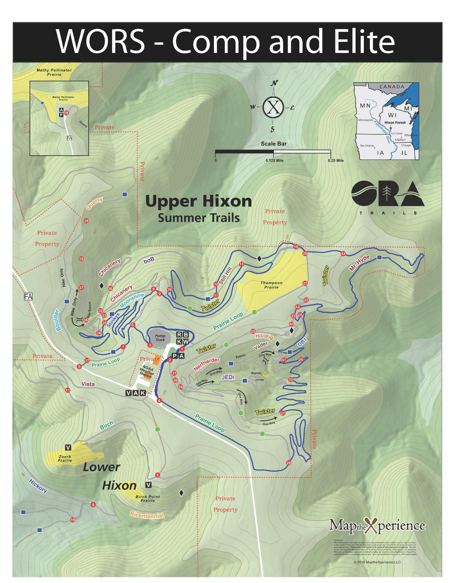

## Podium Ceremony

The top 5 UCI Men Elite, Women Elite, UCI Men Junior and UCI Women Junior must attend the podium ceremony, properly dressed in their team kit (jersey and shorts).

The podium ceremony for UCI Men Elite/UCI Men Junior, and UCI Women Elite/UCI Women Junior will be done at the conclusion of their races.

The podium ceremony for XCC (short track) races will be at 2:10pm, 3:10pm, 4:10pm and 5:10pm. for the preceding 2 races.

The times mentioned in the event schedule above are approximate. The top 5 riders are required to be in the podium area during the official ceremony.

## Bike Wash

Available near the registration tent area.

## The 80% Rule

As per the UCI Regulations, the 80% Rule will be in effect for UCI Men Elite, Women Elite, UCI Men Junior and UCI Women Junior categories. Riders instructed by the Commissaires to withdraw from the race at the 80% Zone must follow the instructions.

## Anti-doping

Given the high level of sanction, it is anticipated that this event may be selected for doping controls. The doping control station will be located within the venue, close to the start / finish area. A sign will be posted designating the doping station.

Chaperones will be present to notify the riders who are selected for testing, Any rider entered in the event may be selected for testing – not just those who place on the podium. As usual, chaperones will first accompany riders selected for testing to the podium (if the riders are required there) and then to the doping control station.

All riders selected for testing must bring a piece of government-issued photo identification and their UCI International License with them to present to the Doping Control Officer.

## Results / Timing

Races will be timed with timing chips and a Lynx photo-finish camera.

Results will be posted on the results board, near the S/F-Podium area, after each race finish. Once the results are posted, there is a 15 minute protest period. If you feel a mistake has been made, you must call errors to the attention of the Chief Judge during the protest period. The Chief Judge can be found near the finish line area and is the official responsible for determining the race results. The Chief Judge will try to correct any result errors before the official ceremony.

## First Aid and Hospital

Wisconsin Bike Patrol will be on site at all times during the event, dispatching will be done by this team. There are two regional hospitals in La Crosse, including a Level 1 trauma center.

|  |  |
| --- | --- |
| **Emplify Health (Gundersen Health System)**  1900 South Ave La Crosse, WI 54601  Phone: (608) 775-3128 | **Mayo Clinic Health System in La Crosse**  700 West Ave S La Crosse, WI 54601  Phone: (608) 785-0940 |

## Officials

|  |  |
| --- | --- |
| Position | Name |
| UCI PCP | Uğur Tosun |
| USAC ACR | TBD |
| Secretary | Leslie Ramsay |
| Finish Judge | TBD |
| Assistant Referee | Alan Stewart |
| Assistant Referee | Julie Renquin |

## UCI MTB Points

|  |  |  |  |
| --- | --- | --- | --- |
|  | **XCO (Cross Country)** | | **XCC (Short Track)** |
| **Place** | **Men/Women Elite** ***- Class 2 -*** | **Men/Women Junior** ***- XCO Junior -*** | **Men/Women Elite** ***- Class 3 -*** |
| **1** | 30 | 20 | 10 |
| **2** | 20 | 18 | 6 |
| **3** | 15 | 16 | 4 |
| **4** | 12 | 14 | 2 |
| **5** | 10 | 12 | 1 |
| **6** | 8 | 10 | - |
| **7** | 6 | 8 | - |
| **8** | 4 | 6 | - |
| **9** | 2 | 4 | - |
| **10** | 1 | 2 | - |

## UCI Prize List / Distribution

|  |  |  |  |
| --- | --- | --- | --- |
|  | **XCO (Class 2)** | | **XCC - Short Track (Class 3)** |
| **Place** | **Men/Women Elite** | **Men/Women Juniors** | **Men/Women Elite** |
| **1** | $259.65 | $83.09 | $207.72 |
| **2** | $207.72 | $67.51 | $155.79 |
| **3** | $155.79 | $51.93 | $103.86 |
| **4** | $129.83 | $31.16 | $77.90 |
| **5** | $103.86 | $25.97 | $51.93 |
| **6** | $93.47 |  |  |
| **7** | $83.09 |  |  |
| **8** | $72.70 |  |  |
| **9** | $62.32 |  |  |
| **10** | $51.93 |  |  |
| **TOTAL** | **$1,220.36** | **$259.66** | **$597.20** |

*\* Prize list is based on the UCI Financial Obligations.*

Prize money distribution will take place after the podium ceremony of the respective race. Riders who finish in payout positions must attend the podium ceremony to receive their prize money in the form of a check. No prize money will be mailed or transferred via bank. Failure to attend the official ceremony will result in forfeiture of the prize money.